**Data Visualization**

Table of Contents

Introduction 2

Data Acquisition 2

Part 0 - Loading Dataset 2

Part 1 – Line Plot 3

Part 2 – Histogram of GHI Scores 4

Part 3 – Distribution of Score Categories 5

References 6

# Introduction

The Global Hunger Index (GHI) is an annual survey that assesses and ranks the severity of a variety of hunger indicators across the globe, including malnutrition and the mortality rate of children, as well as across various regions and individual countries. Its purpose is to broaden people's knowledge and comprehension of the struggle against hunger and to focus attention on the areas of the world where additional resources are required the most to put an end to the problem of hunger.

# Data Acquisition

We obtained the CSV data from Kaggle. The data is hosted at the URL <https://www.kaggle.com/datasets/whenamancodes/the-global-hunger-index> and one can access it without any cost. Data has information on 128 unique political entities – countries and territories. Data is available over multiple years.

# Part 0 - Loading Dataset

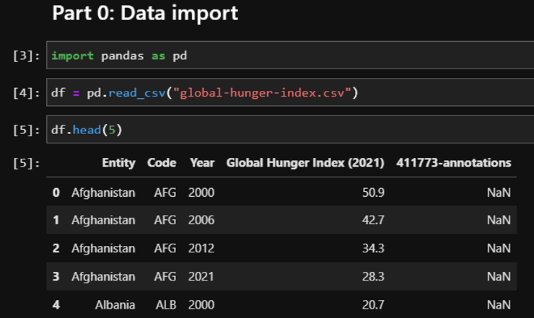

We use the Pandas library in a Jupyter Notebook environment to load the data from the CSV file into the Pandas dataframe. We also check the data values using the head function on the dataframe.

# Part 1 – Line Plot

"""

Input: A Python list of all the country codes to be plotted

Caution: The country in the list must have data for four years

Output: The plot with multiple lines

"""

def plot_countries(country_codes):

    x = ["2000", "2006", "2012", "2021"]

    for code in country_codes:

        y = [z for z in df[df["Code"] == code]["Global Hunger Index (2021)"]]

        plt.plot(x, y, label = code)

    plt.legend()

    plt.title("The Global Hunger Index")

    plt.xlabel("Year of Index")

    plt.ylabel("Score of Index")

    plt.show()

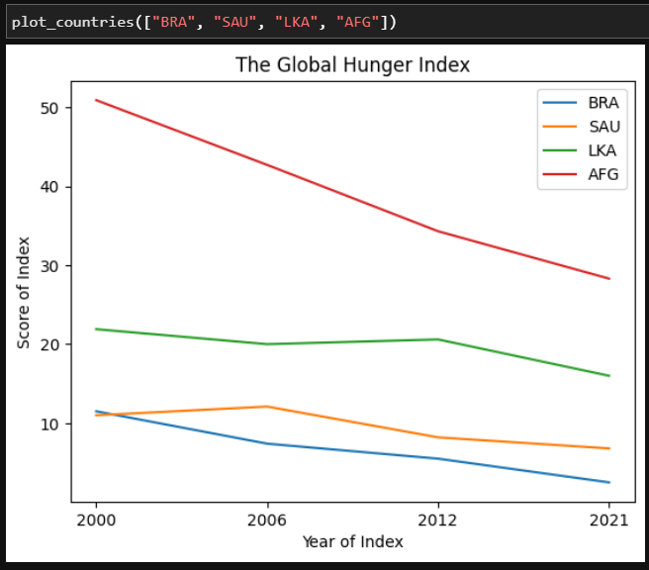

We plot the GHI scores data over four years (2000, 2006, 2012 and 2021) from four countries – Brazil, Kingdom of Saudi Arabia, Sri Lanka, and Afghanistan. We observe that although there is more hunger as per the index in Afghanistan as compared to the other three countries but at the same time, the score is seeing decline in all the four countries plotted.

# Part 2 – Histogram of GHI Scores

"""

Input: A Python number of one of the score observation years

Caution: The year must be there in the dataset

Output: The histogram

"""

def plot_histogram(year_of_score):

    plt.hist(df[df["Year"] == year_of_score]["Global Hunger Index (2021)"], rwidth=0.9)

    plt.title("Histogram of GHI Scores")

    plt.show()

plot_histogram(2021)

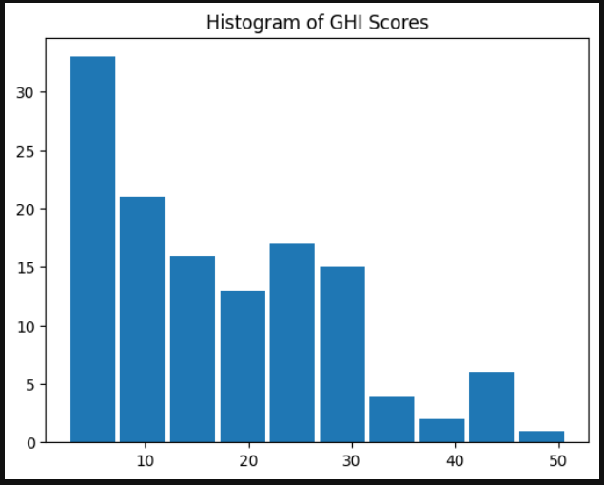

We plot the histogram of the GHI scores of all the countries for the year of 2021 and it is very evident from the histogram that the scores do not follow a normal distribution and they are skewed towards the left.

# Part 3 – Distribution of Score Categories

Based on the values of the GHI score, the categorization is made into labels such as 'Low', 'Moderate', 'Serious', 'Alarming', and 'Extremely alarming'. We made a pie chart to check on the proportional distribution of the score in the whole dataset. We split the pie using the range values and plotted it with labels.

labels = ['Low','Moderate','Serious', 'Alarming', 'Extremely alarming']

df['distribution'] = pd.cut(df['Global Hunger Index (2021)'],

                   (0,10,20,35,50,200),

                   labels=labels)

plt.pie(df.groupby(['distribution'])['Global Hunger Index (2021)'].sum(), labels=labels)

plt.title("Distribution of GHI Score Categories")

plt.show()

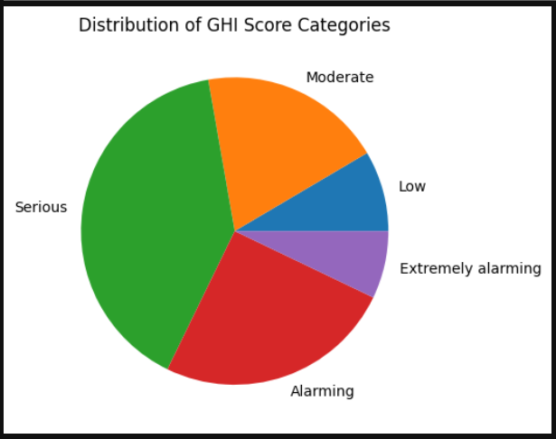

# References

Galea, A. (2018). Beginning Data Science with Python and Jupyter: Use powerful industry-standard tools within Jupyter and the Python ecosystem to unlock new, actionable insights from your data. In *Google Books*. Packt Publishing Ltd.

Toomey, D. (2018). Jupyter Cookbook: Over 75 recipes to perform interactive computing across Python, R, Scala, Spark, JavaScript, and more. In *Google Books*. Packt Publishing Ltd.

Wintjen, M. (2020). Practical Data Analysis Using Jupyter Notebook: Learn how to speak the language of data by extracting useful and actionable insights using Python. In *Google Books*. Packt Publishing Ltd.